**Module 6: Database Services Assignment – 1**

1. **Created an RDS MariaDB database**

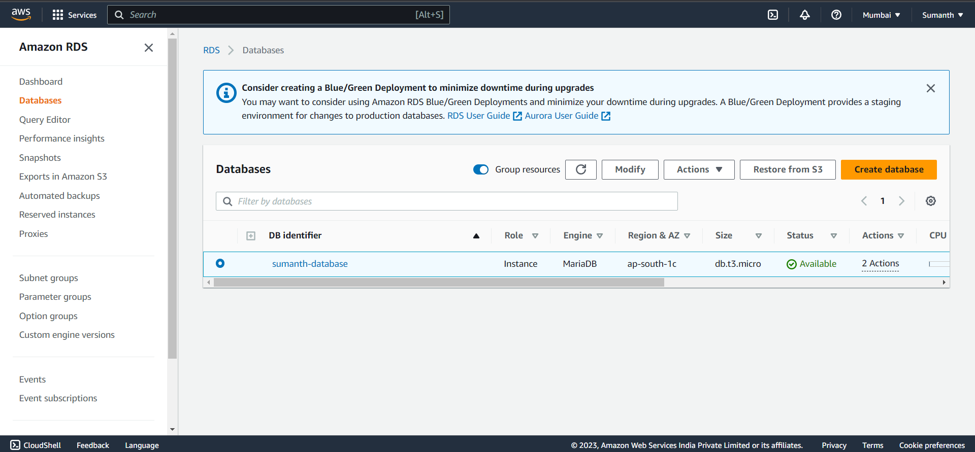

1. **Created an EC2 instance**

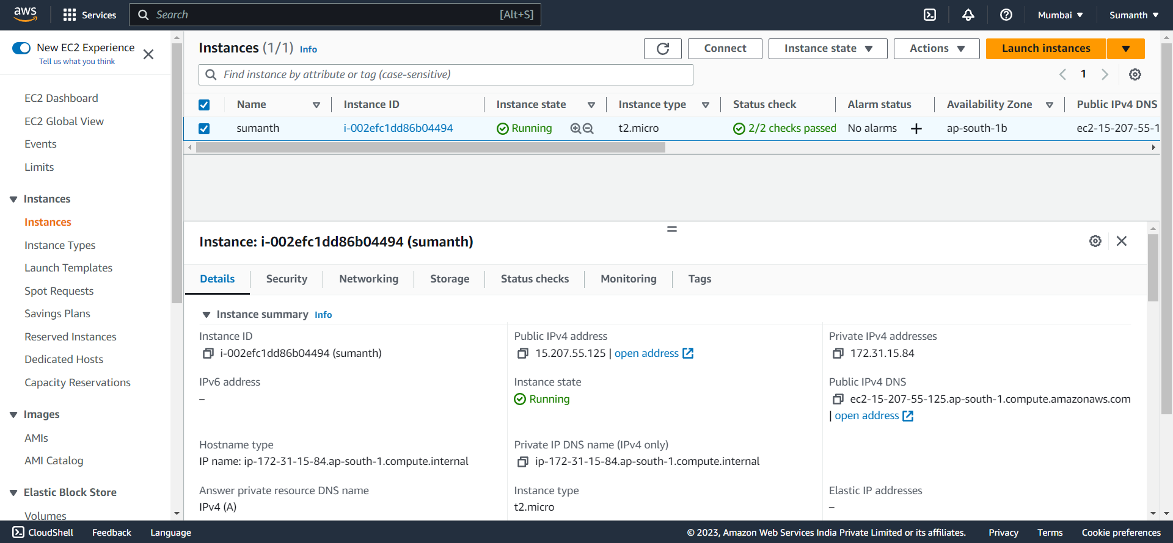

1. **Connected to DB**

